# CHAPTER 1

## INTRODUCTION

In a world of increasing misdirection by journalists in a race to attain more clicks, we are trying to make an open source, moderated platform to bring together the latest sport articles. This sports blog is maintained by a community of true sports enthusiasts who have a real passion to share information about sports.

Sports Blog is a static blog page that is designed to share information on sports and more. This project aims at maintaining all the latest information in the world of sports, every article added is a huge gift to a normal person looking to catch up with the news in the world of sports. Aim is to provide transparency in this field, make the process of sharing of articles hassle free and corruption free and make the world of journalism effective.

### NEED FOR SPORTS BLOG

Many youngsters are very enthusiastic about catching up with sports information in today’s day and age. Our country is moving from a cricket dominated field to a multi-sport embracing nation. These two reasons make a loud call for an all website which talks all sports and maintains quality of information throughout the system. An openly hosted blog is a great solution for the abovementioned needs.

# CHAPTER 2

## REQUIREMENT SPECIFICATION

A high-level requirements specification is required. The purpose of the requirements analysis is to identify requirements for the proposed system. The emphasis is on the discovery of user requirements.

### 2.1 SOFTWARE REQUIREMENTS

Operating System : Any operating system with a browser.

Tools : GIT, Jekyll

### 2.2 HARDWARE REQUIREMENTS

Processor : Any Processor above 500 MHz

RAM : 4GB

Hard Disk : 2 GB free space

Input device : Keyboard, Mouse

Output device : Monitor

System type : 32-bit or 64-bit operating system

### 2.3 FUNCTIONAL REQUIREMENTS

**Home page:** Home page is the first page of the website. Home page contains the links to all the different sports and a little information about the blog

**Blog Page:** In this page, all the articles can be viewed.

**Ranking:** Top athletes and teams in various sports can be found ranked here.

### 2.4 NONFUNCTIONAL REQUIREMENTS:

### PERFORMANCE:

Performance requirements define acceptable response times for system functionality.

* The load time for user interface screens shall take no longer than 5 seconds.

### RELIABILITY:

* Avoid incorrect storage of records.

### SECURITY:

* HTTPS connection.

### FLEXIBILITY:

* The system keeps on updating the data with very little delay.

### MAINTAINABILITY:

* GitHub is very reliable and requires almost no maintenance.

# CHAPTER 3

## OBJECTIVE OF THE PROJECT

The main objective of this application is to automate the complete operations of a blog. They need maintain hundreds of thousands of articles. Also, searching should be very fast so they can find required details instantly.

To develop a web-based portal to facilitate the co-ordination between writers and readers. This system makes conveniently available good quality and fool-proof information, which can be provided in a sound, ethical and acceptable manner, consistent with the long-term well-being of the community. It actively encourages voluntary updating of the site, motivates to maintain a well-indexed record of articles and educate the community on the benefits of being active in sports.

The system will provide the user the option to look at the details of the current rankings of teams and players. There is also an added benefit of finding catchy wallpapers designed specially.

# CHAPTER 4

## SYSTEM DESIGN

### 4.1 FLOW OF WEB PAGES

A use case diagram at its simplest is a representation of a user's interaction with the system that shows the relationship between the user and the different [use cases](https://en.wikipedia.org/wiki/Use_case) in which the user is involved. Figure 4.1 below shows the use case diagram for this website.

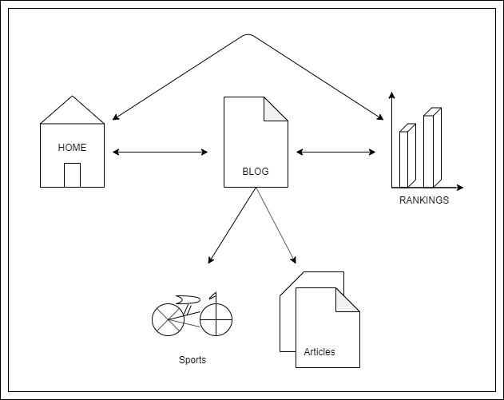

**Figure 4.1: Flow of Web Pages**

# CHAPTER 5

## IMPLEMENTATION

### 5.1 SOURCE CODE

### About blog.html

---

title: About Blog

icon: fa-user

order: 3

---

<p>This blog is a curation of some of the most amazing sports news found on the internet, curated by a community of open source users</p>

### Categories.html

---

title: Categories

icon: fa-th

order: 2

---

<p>You can find the various categories of blog below</p>

<div class="row">

<div class="4u 12u$(mobile)">

<div class="item">

<a href="#" class="image fit"><img src="{{ 'assets/images/basketball.svg' | relative_url }}" alt="Rankings" /></a>

<header>

<h3>Basketball</h3>

</header>

</div>

<div class="item">

<a href="#" class="image fit"><img src="{{ 'assets/images/football.svg' | relative_url }}" alt="Magna Nullam" /></a>

<header>

<h3>Football</h3>

</header>

</div>

</div>

<div class="4u 12u$(mobile)">

<div class="item">

<a href="#" class="image fit"><img src="{{ 'assets/images/cricket.svg' | relative_url }}" alt="Rhoncus Semper" /></a>

<header>

<h3>Cricket</h3>

</header>

</div>

<div class="item">

<a href="#" class="image fit"><img src="{{ 'assets/images/tennis.svg' | relative_url }}" alt="Natoque Vitae" /></a>

<header>

<h3>Tennis</h3>

</header>

</div>

</div>

<div class="4u 12u$(mobile)">

<div class="item">

<a href="#" class="image fit"><img src="{{ 'assets/images/running.svg' | relative_url }}" alt="Dolor Penatibus" /></a>

<header>

<h3>Atheletics</h3>

</header>

</div>

<div class="item">

<a href="#" class="image fit"><img src="{{ 'assets/images/swimming.svg' | relative_url }}" alt="Orci Convallis" /></a>

<header>

<h3>Aquatics</h3>

</header>

</div>

</div>

</div>

### 

### Intro.html

---

title: Intro

cover-photo: assets/images/banner.jpg

cover-photo-alt: cover photo

auto-header: none

icon: fa-comment

order: 1

---

<header>

<h2 class="alt">This is an open source sport blog for all journalists to post, it is driven by a community of writers</p>

</header>

<footer>

<a href="#categories" class="button scrolly">Categories</a>

</footer>

### Blog.html

---

layout: blog

title: Articles

icon: fa-pencil-alt

order: 2

---

### Rankings.md

---

title: Rankings

subtitle: Ranks of top athletes and teams

layout: "page"

icon: fa-trophy

order: 3

---

<div class="row">

<div class="item">

<a href="#" class="image fit"><img src="{{ 'assets/rankings/cricket test ranking.PNG' | relative_url }}" alt="Rankings" /></a>

<header>

<h3>Cricket Test Team </h3>

</header>

</div>

<div class="item">

<a href="#" class="image fit"><img src="{{ 'assets/rankings/cricket odi ranking.png' | relative_url }}" alt="Magna Nullam" /></a>

<header>

<h3>Cricket ODI Team </h3>

</header>

</div>

<div class="item">

<a href="#" class="image fit"><img src="{{ 'assets/rankings/cricket t20 ranking.PNG' | relative_url }}" alt="Rhoncus Semper" /></a>

<header>

<h3>Cricket T20 Team </h3>

</header>

</div>

<div class="item">

<a href="#" class="image fit"><img src="{{ 'assets/rankings/test batsmen.PNG' | relative_url }}" alt="Natoque Vitae" /></a>

<header>

<h3>Cricket Test Batsmen </h3>

</header>

</div>

<div class="item">

<a href="#" class="image fit"><img src="{{ 'assets/rankings/test bowlers.PNG' | relative_url }}" alt="Dolor Penatibus" /></a>

<header>

<h3>Cricket Test Bowler </h3>

</header>

</div>

<div class="item">

<a href="#" class="image fit"><img src="{{ 'assets/rankings/odi batsmen.PNG' | relative_url }}" alt="Orci Convallis" /></a>

<header>

<h3>Cricket ODI Batsmen </h3>

</header>

</div>

<div class="item">

<a href="#" class="image fit"><img src="{{ 'assets/rankings/odi bowlers.PNG' | relative_url }}" alt="Orci Convallis" /></a>

<header>

<h3>Cricket ODI Bowlers</h3>

</header>

</div>

<div class="item">

<a href="#" class="image fit"><img src="{{ 'assets/rankings/t20 batsmen.PNG' | relative_url }}" alt="Orci Convallis" /></a>

<header>

<h3>Cricket T20 Batsmen</h3>

</header>

</div>

<div class="item">

<a href="#" class="image fit"><img src="{{ 'assets/rankings/t20 bowlers.PNG' | relative_url }}" alt="Orci Convallis" /></a>

<header>

<h3>Cricket ODI Batsmen</h3>

</header>

</div>

<div class="item">

<a href="#" class="image fit"><img src="{{ 'assets/rankings/tennis ranking.png' | relative_url }}" alt="Orci Convallis" /></a>

<header>

<h3>Tennis</h3>

</header>

</div>

<div class="item">

<a href="#" class="image fit"><img src="{{ 'assets/rankings/fifa rankings.png' | relative_url }}" alt="Orci Convallis" /></a>

<header>

<h3>Football</h3>

</header>

</div>

<div class="item">

<a href="#" class="image fit"><img src="{{ 'assets/rankings/fiba ranking.PNG' | relative_url }}" alt="Orci Convallis" /></a>

<header>

<h3>BasketBall</h3>

</header>

</div>

</div>

### Walpapers.md

---

title: Rankings

subtitle: Ranks of top athletes and teams

layout: "page"

icon: fa-trophy

order: 5

---

<div class="row">

<div class="item">

<a href="#" class="image fit"><img src="{{ 'assets/rankings/cricket test ranking.PNG' | relative_url }}" alt="Rankings" /></a>

<header>

<h3>Cricket Test Team </h3>

</header>

</div>

<div class="item">

<a href="#" class="image fit"><img src="{{ 'assets/rankings/cricket odi ranking.png' | relative_url }}" alt="Magna Nullam" /></a>

<header>

<h3>Cricket ODI Team </h3>

</header>

</div>

<div class="item">

<a href="#" class="image fit"><img src="{{ 'assets/rankings/cricket t20 ranking.PNG' | relative_url }}" alt="Rhoncus Semper" /></a>

<header>

<h3>Cricket T20 Team </h3>

</header>

</div>

<div class="item">

<a href="#" class="image fit"><img src="{{ 'assets/rankings/test batsmen.PNG' | relative_url }}" alt="Natoque Vitae" /></a>

<header>

<h3>Cricket Test Batsmen </h3>

</header>

</div>

<div class="item">

<a href="#" class="image fit"><img src="{{ 'assets/rankings/test bowlers.PNG' | relative_url }}" alt="Dolor Penatibus" /></a>

<header>

<h3>Cricket Test Bowler </h3>

</header>

</div>

<div class="item">

<a href="#" class="image fit"><img src="{{ 'assets/rankings/odi batsmen.PNG' | relative_url }}" alt="Orci Convallis" /></a>

<header>

<h3>Cricket ODI Batsmen </h3>

</header>

</div>

<div class="item">

<a href="#" class="image fit"><img src="{{ 'assets/rankings/odi bowlers.PNG' | relative_url }}" alt="Orci Convallis" /></a>

<header>

<h3>Cricket ODI Bowlers</h3>

</header>

</div>

<div class="item">

<a href="#" class="image fit"><img src="{{ 'assets/rankings/t20 batsmen.PNG' | relative_url }}" alt="Orci Convallis" /></a>

<header>

<h3>Cricket T20 Batsmen</h3>

</header>

</div>

<div class="item">

<a href="#" class="image fit"><img src="{{ 'assets/rankings/t20 bowlers.PNG' | relative_url }}" alt="Orci Convallis" /></a>

<header>

<h3>Cricket ODI Batsmen</h3>

</header>

</div>

<div class="item">

<a href="#" class="image fit"><img src="{{ 'assets/rankings/tennis ranking.png' | relative_url }}" alt="Orci Convallis" /></a>

<header>

<h3>Tennis</h3>

</header>

</div>

<div class="item">

<a href="#" class="image fit"><img src="{{ 'assets/rankings/fifa rankings.png' | relative_url }}" alt="Orci Convallis" /></a>

<header>

<h3>Football</h3>

</header>

</div>

<div class="item">

<a href="#" class="image fit"><img src="{{ 'assets/rankings/fiba ranking.PNG' | relative_url }}" alt="Orci Convallis" /></a>

<header>

<h3>BasketBall</h3>

</header>

</div>

</div>

# CHAPTER 6

## TESTING

This chapter gives the outline of the testing methods that are carried out to get a bug free system. Quality can be achieved by testing the product using different techniques at different phases of the project development. The purpose of testing is to discover errors. Testing is the process of trying to discover every conceivable fault or weakness in a work product. It provides a way to check the functionality of components sub-assemblies and/or a finished product. It is the process of exercising software with the intent of ensuring that the Software system meets its requirements and user expectations and does not fail in an unacceptable manner. There are various types of test. Each test type addresses a specific testing requirement.

### 6.1 TESTING PROCESS

Testing is an integral part of software development. Testing process certifies whether the product that is developed compiles with the standards that it was designed to. Testing process involves building of test cases against which the product has to be tested.

### 6.2 TESTING OBJECTIVES

The main objectives of testing process are as follows.

* Testing is a process of executing a program with the intent of finding an error.
* A good test case is one that has high probability of finding undiscovered error.
* A successful test is one that uncovers the undiscovered error.

**Table 5.1: Test cases**

|  |  |  |  |  |
| --- | --- | --- | --- | --- |
| **S.NO** | **CASE** | **INPUT** | **EXPECTED OUTPUT** | **ACTUAL OUTPUT** |
| 1 | Load Website | URL | The Website loads | The Website loads |
| 2 | Add Articles | .md files | New article added | New article Added |
| 3 | Download wallpapers | Click on the image | Wallpaper downloads | Wallpaper downloads |
| 4 | Open sports.html | Click on “sports” in nav-bar | Articles sorted according to sports loads | Articles sorted according to sports loads |

# CHAPTER 7

## RESULTS

This section describes the screens of the “Sports blog”.

The snapshots are shown below for each module.

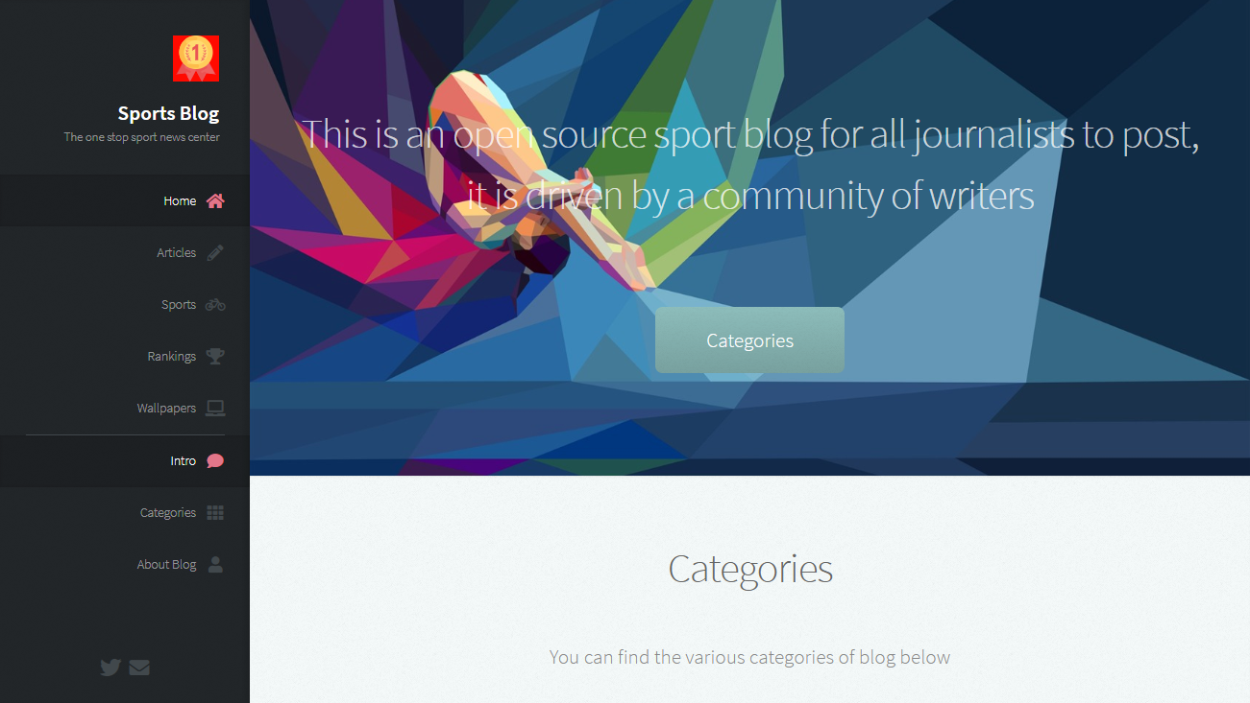

### Figure 7.1: Home page

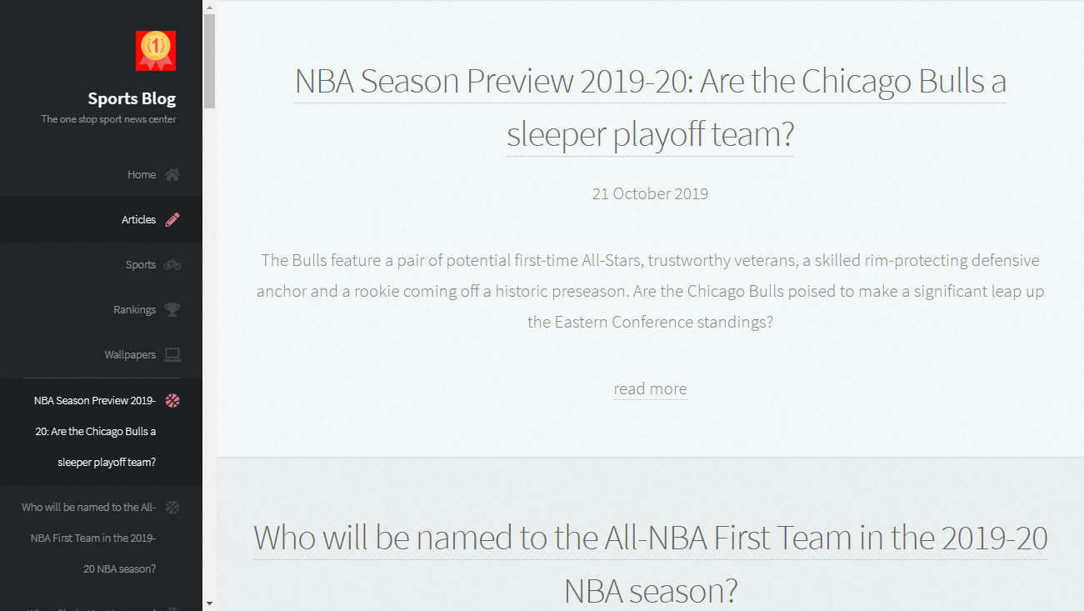

### Figure 7.2: Blog page

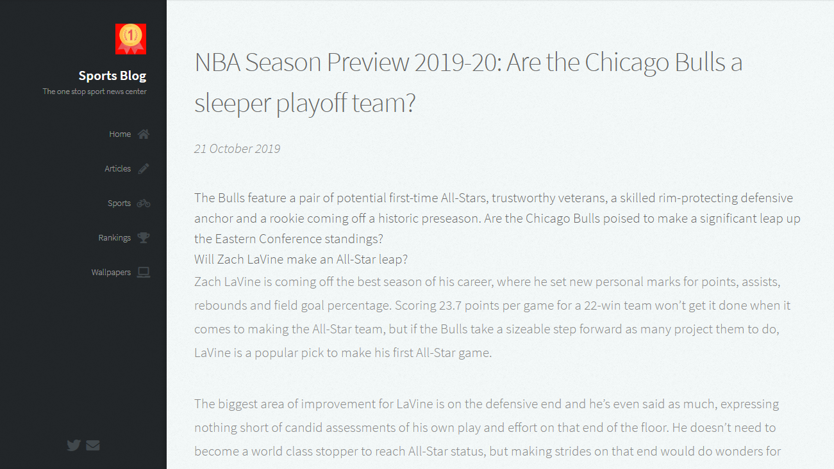

### Figure 7.3: Article view

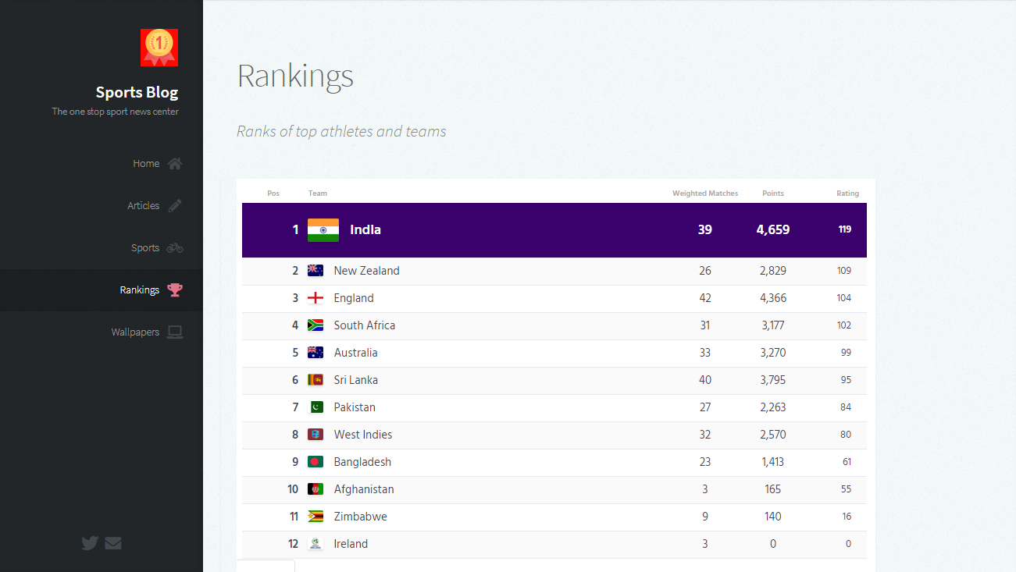

### Figure 7.4: Sport rankings page

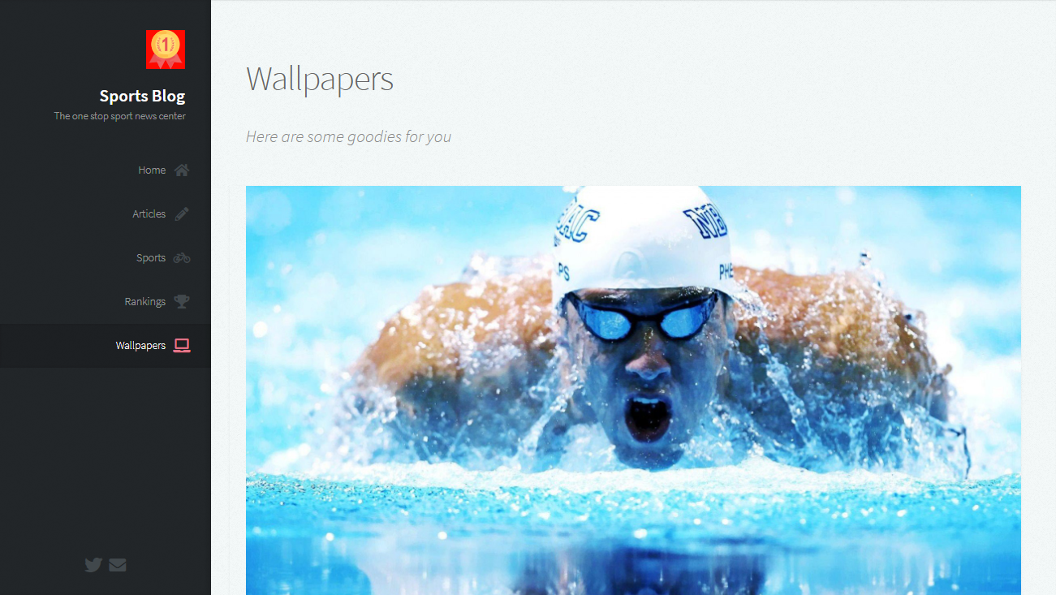

### Figure 7.5: Wallpaper gallery

## CONCLUSION

With the theoretical inclination of our syllabus it becomes very essential to take the at most advantage of any opportunity of gaining practical experience that comes along. The building blocks of this Major Project” Sports blog” was one of these opportunities. It gave us the requisite practical knowledge to supplement the already taught theoretical concepts thus making us more competent as a computer engineer. The project from a personal point of view also helped us in understanding the following aspects of project development:

* The planning that goes into implementing a project.
* The importance of proper planning and an organized methodology.
* The key element of team spirit and co-ordination in a successful project.

## BIBILIOGRAPHY

[1]. [https://www.w3schools.com](https://www.w3schools.com/)

[2]. Randy Connolly, Ricardo Hoar, **“Fundamentals of Web Development”**, 1st Edition, Pearson Education India.

[3]. Robin Nixon, “Learning PHP, MySQL & JavaScript with jQuery, CSS and HTML5”, 4th Edition, O’Reilly Publications, 2015.